STUDENT NAME : THANIKONDA DIVYA
REGISTRATION NUMBER: 192411120

COURSE CODE: CSA1401

LAB:

1.The Company ABC runs with employees with several departments. The Organization manager had all the mobile numbers of employees. Assume that you are the manager and need to verify the valid mobile numbers because there may be some invalid numbers present. Implement a LEX program to check whether the mobile number is valid or not.

CODE:

%{
%}

%%

[6-9][0-9]{9} {printf("\nMobile Number Valid\n");}

.+ {printf("\nMobile Number Invalid\n");}

%%
int yywrap(void) {}

int main()
{
printf("\nEnter Mobile Number : ");
yylex();
printf("\n");

}

OUTPUT:

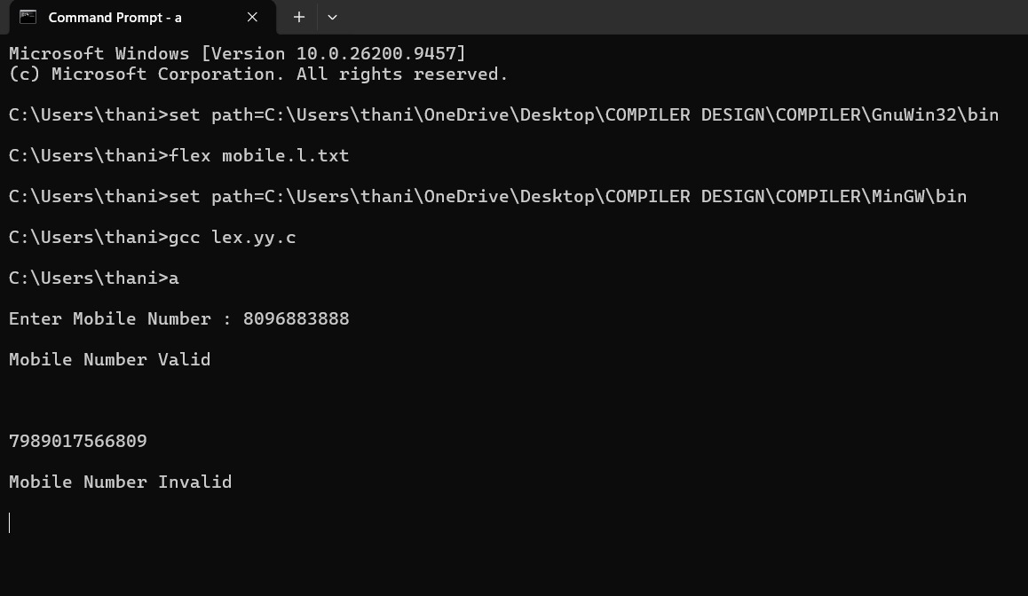

- Write a LEX Program to check the email address is valid or not.

CODE:

%{
#include <stdio.h>
%}

%%
^[a-zA-Z0-9._%+-]+@[a-zA-Z0-9.-]+\.[a-zA-Z]{2,}$ { printf("Email Address Valid\n"); }
.* { printf("Email Address Invalid\n"); }
%%

int yywrap()
{
return 1;
}

int main()
{
printf("Enter Email Address: ");
yylex();
return 0;
}

OUTPUT:

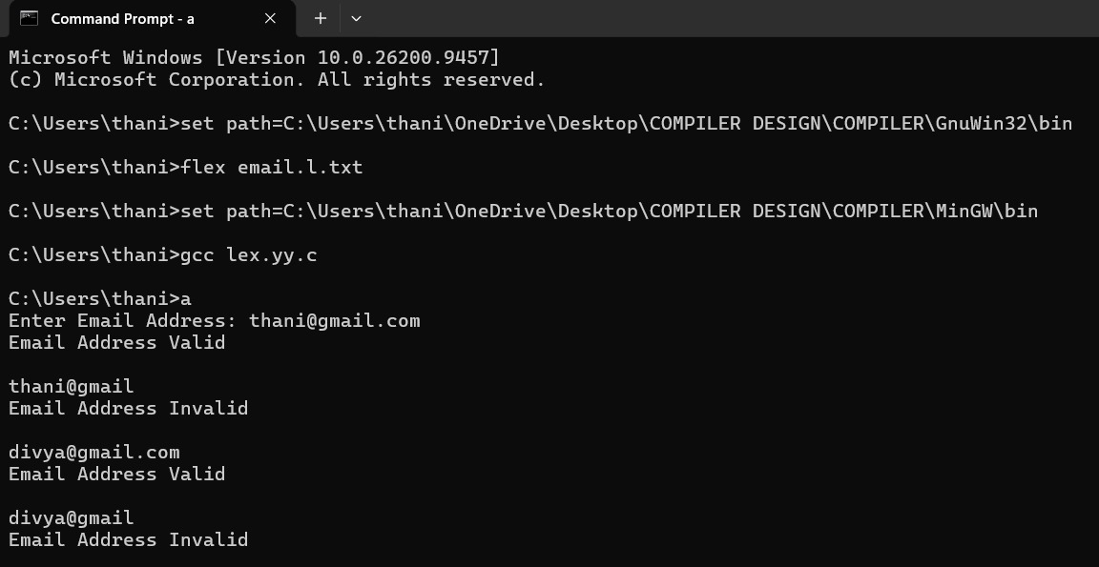

- Write a LEX program to check whether the given input is a digit or not.

CODE:

%{
#include <stdio.h>
%}

%%
^[0-9]$ { printf("Given input is a Digit\n"); }
.* { printf("Given input is Not a Digit\n"); }
%%

int yywrap()
{
return 1;
}

int main()
{
printf("Enter an input: ");
yylex();
return 0;
}

OUTPUT:
